**Constant variables Example**

**Example part 1:**

Create class Test with following members:

* public constant integer variable var1 = 20.
* public constant integer variable var2 .
* public constant integer variable var3 .
* constructor that takes one integer parameter then assigns its value to var2 and assigns 40 to var3.

sol:

**public class Test {**

**public final int var1=20;**

**public final int var2;**

**public final int var3;**

**public Test(int v)**

**{**

**var2=v;**

**var3=40;**

**}**

**}**

**Example part 2:**

In the main method create an object from class Test then try to change the values of var1, var2 and var3 using this object.

Did you succeed? Why?

sol:

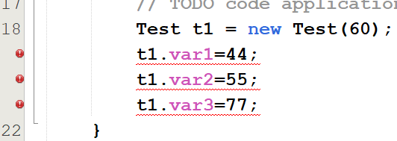

**No, since constant variable can not be changed**

**Example part 3:**

Repeat **Example part1** using static constant instead of constant variables var1, var2 and var3.

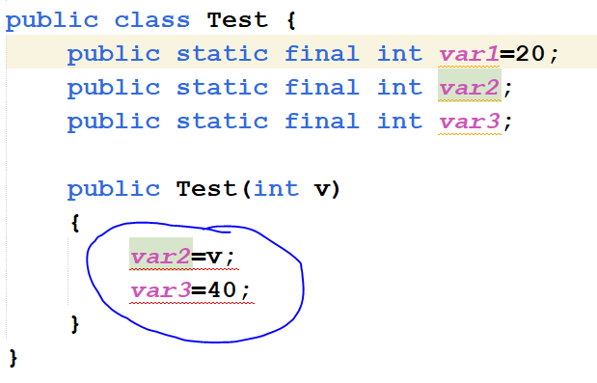

**error: cannot assign a value to final variable var2 and var3 inside the constructor instead assign values for both variables in declaration statements,**

Notes:

* Java constant variables are declared using the keyword **final**.
* A constant variable can be assigned a value when it is declared.
* Once a constant variable is assigned a value, its value can be used in the application but cannot be changed.
* It is possible to declare constant variables also as static variables **(static final).**